# Information Visualization

# CHECKPOINT III: Visualization Sketch

G22 - A

1. **Overview**

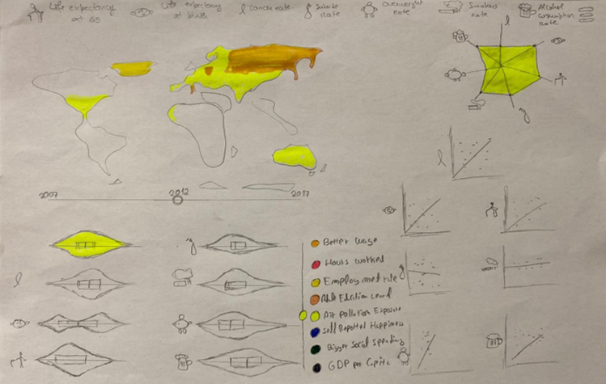We start by having a slider where the user can select the health influencers he wants to analyse. And a slider to limit the years being analysed.

The data being shown is all connected, which means that when a user moves the time slider or the potential health factor slider, the data being shown changes in all the idioms.

We have the following idioms:

1. **Choropleth map**

This map will change the colour based on the health influencers selected on the slider described above.

The user can then use the map as a slider, where he can click in a country to highlight the data being shown to that country.

1. **Scatter plot**

We will have 1 scatter plot per each variable of health being analysed. This means we have 7 different scatter plots as small multiples. On the x axis we have the health factor and on the y axis we have the habit selected on the slider described above. The point of the country selected on the choropleth map will have highier luminance so the user can identify the country selected and compare it to the rest of the countries. You can also click or hover over a dot to see what country it is.

1. **Star plot**

In this plot we’ll have the correlation coefficient between each health variable and the variable selected on the slider.

1. **Violin plot**

Here once again we’ll have a violin plot per each health variable, which means we’ll have seven different violin plots. Each violin plot will show the distribution of countries in relation with one of the health variables. We will also have an 8th violon plot to understand the evolition of the selected variable, as well as the health factors (by using year slider).

1. **Health influencer slider**

You can use this to select the health influencer you want to analyze.

1. **Health influencer label and Pictogram legend**

This serves as a label for the icons close to the plots, so the user can understand which data is in the plots. The Pictogram legend associates the pictograms with their meaning.

1. **Years slider**

This allows the user to select the year he wants to analyze.

**2. Visual Encoding**

1. **Choropleth map**

Map -> Colour: filling each country with the colour of the selected variable.

Channel -> colour -> hue: a higher value for the hue represents a higher value of the selected variable.

Channel -> colour -> lightness: if a point from a country is selected on a scatter plot, the lightness goes up on the map.

1. **Scatter plot**

Marks -> Point: represents a pair (health variable, health influencer)

Marks -> Line: represents the linear approximation of the scatterplot between the 2 variables.

Channel -> position: represents the position of the point in a Cartesian axis.

Pictograph -> Represents the respective health variable being correlated with health influencer

1. **Star plot**

Marks -> Point: represents the correlation coefficient normalized between 0 and 1.

Channel -> colour -> hue: The colour of the area between the points in the start chart represents the variable being analyzed.

Pictograph -> Represents the respective health variable being correlated with health influencer

Channel -> Colour: coulor represents the selected variable.

1. **Violin plot**

Pictograph -> Represents the respective health variable

Curve -> Represents the distribution of each of the health variables and the selected health influencer

Size -> Is proportional to cardinality countries of the value interval

Channel -> Colour: the colour of the first violin plot represents the selected variable

1. **Health influencer slider**

Channel -> position: represents the health influencer being displayed

Channel -> colour: represents the health influencer being displayed

1. **Health influencer label**

Channel -> position: represents the year being displayed

Channel -> colour: represents the relation between the coulor with each influencer (word on its right)

1. **Years slider**Channel -> position: represents the year being displayed  
   Channel -> colour: represents the relation between the coulor with each influencer (word on its right)
2. **Health influencer legend**Channel -> colour: represents the relation between the coulor with each influencer (word on its right)

**3. Answering the questions**

* + - 1. **Question 1:** Does a better wage mean a healthier life or a longer life expectancy?
         1. - You can see this by selecting the wage mean on the slider and looking at the scatter chart of life expectancy.
    1. **Question 2:** What is the optimal number of hours to work that lead to a healthier life or more life expectancy?
       1. - You can see this by selecting the hours worked on the slider and looking at the violin chart of life expectancy to see the tendency.



1

Select potential health influencer

2

Select year

Select country

3

4

Look at the data

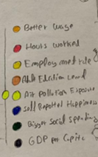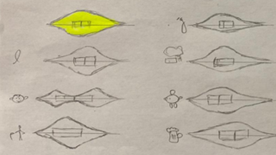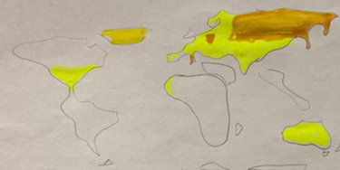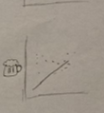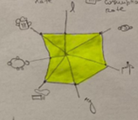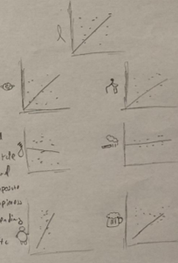

2

Select

Understand the evolution

Is that correlated to health?

Are there many exceptions?

Where?

* + - 1. **Question 3:** What is the relationship between, more people working and being healthier and live more?
      2. - You can see this by selecting the employment rate on the slider and looking at the scatter chart to compare the countries, and then to the violin chart to see the tendency.
      3. **Question 4:** How does adult education influence our health?
      4. - You can see this by selecting adult education on the slider and looking at the scatter charts and the violin charts.
      5. **Question 5:** How does air exposure affect our health?
      6. - You can see this by selecting air exposure on the slider and looking at the violin charts to see the tendency.
      7. **Question 6:** How does self-reported happiness corelates to Alcohol consumption, Smoking habits and Suicide rates?

- You can see this by selecting self-reported happiness on the slider and looking at the scatter chart for comparison between countries of alcohol consumption, smoking habits and suicide rates. And in the violin chart to analyse tendencies

**Question 7:** Does a bigger social spending or a higher GDP in general influences people to live more and suicide, smoke and drink less?

- You can see this by selecting social spending or GDP on the slider and looking at the scatter chart of life expectancy, suicide rate

**The questions proposed previously are quite similar to question 1 in therms of analysis. So we proposed ather related questios as well. To show the versatility of the visualization.**

**Other questions:**

1. Select

1. Select

2. Slide through time

3. Look at distributions evolving



1. Select 2. Look at the map



|  |  |
| --- | --- |
| Where is the wage higher? | Are Is there a good correlation between Self reported happiness and drinking alcohol?  Uma imagem com texto  Descrição gerada automaticamenteUma imagem com texto, quadro branco  Descrição gerada automaticamenteUma imagem com texto, mapa  Descrição gerada automaticamente  1. Select  3. Why that correlation number? Look at the scatter plot  2. Look at star plot with air pollution exposure as the selected variable |
| Are people getting unhappier?  2.Look at the map  1. Select | Are people in Asia Working more hours? |

1. Select

2. Look at Asia in the map, is the orange stronger?